Shalehills DEM Adjustment:

Shalehills is a very small watershed (approx. 8 ha) yet its hydrology is highly dependent on its geomorphology. Existing elevation data for the basin consisted of a USGS 10m resolution DEM and 1m DEM of unknown origin that was utilized by Duffy (1996) in a soil moisture study based on historical data.

Field observations and GPS mapping of topographic depressions (i.e. swales/draws) and the stream revealed that the existing DEMs failed to accurately represent the catchment’s geomorphology. It was therefore necessary to edit an existing terrain model to impose observed terrain features.

Evaluation of the existing DEMs indicated that they did not match one another. Because the origin of the 1 m model was unknown, it was decided to edit the USGS 10 m DEM.

Field data collection and data processing steps undertaken are described:

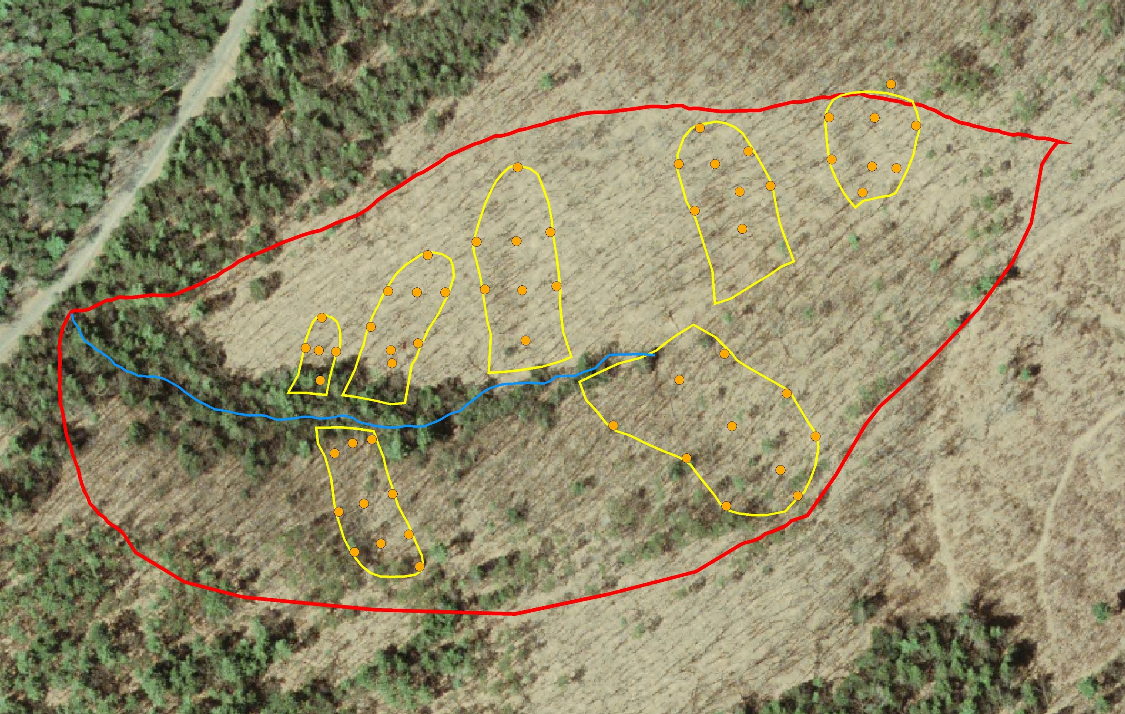
- Utilize GPS to map the location of the swale boundaries and slope breakpoints along the center of the swale.

- Record angle between swale center points and edges using a field clinometer
- Calculate the planimetric distance between the swale center points and edge points and use with angles to determine vertical displacement from edge to center of swale.

- Calculate the corrected swale center points as the difference between edge elevation (from USGS DEM) and vertical displacement.

- Measure distance from swale base to each point and determine the function that describes the elevation profile of each swale. An example profile for swale #4 is shown in Figure X.
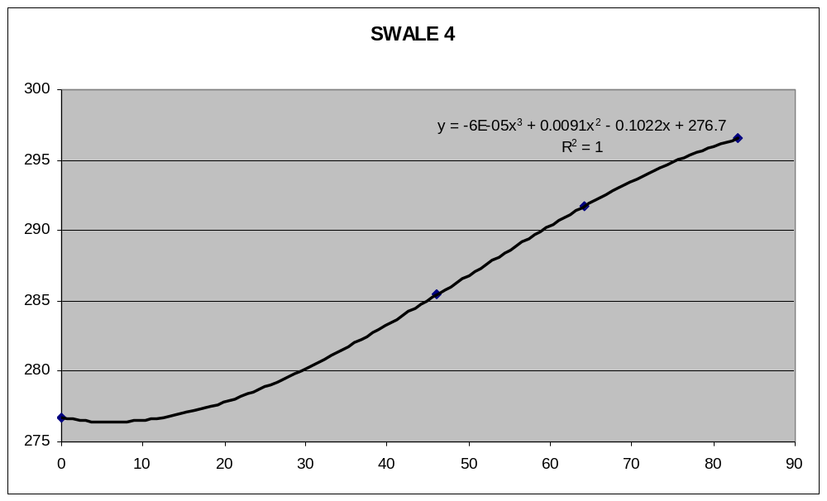
- Utilize the function (either a 2nd or 3rd order polynomial) to determine the elevation along intermediate swale center points that were not GPS sampled.

- Digitize these points to create a shapefile of corrected elevation points

- Resample the 10m USGS DEM to 3 m and run a 10x10 low pass filter to smooth the surface.

- Convert this grid to a point shapefile.
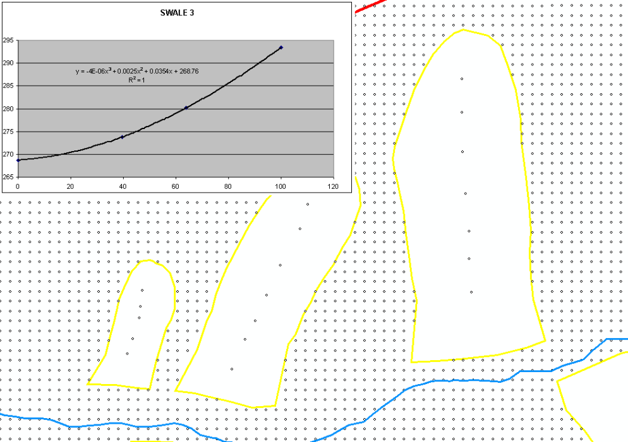
- Remove elevation points that fall within the swale boundaries and replace them with the swale center points. (Fig.X)
- Utilize the Regularized Spline function in ArcGIS 3D analyst. Parameters used were 12 and 0.1 for the number of points and weight, respectively. Resulting raster resolution was set to 3 m. This layer was smoothed with at 3x3 low pass filter. Fig X depicts a 3D rendering of the elevation model before and after adjustment.

- The AGREE method (available with ArcHydo Tools) of DEM conditioning was used to “burn” the stream vector into the elevation surface. (http://www.ce.utexas.edu/prof/maidment/GISHYDRO/ferdi/research/agree/agree.html) This layer was smoothed with at 3x3 low pass filter. The following depicts a 3D rendering of the elevation model before and after adjustment.

Duffy, C. J., A Two-state Integral-balance Model for Soil Moisture and Groundwater Dynamics in Complex Terrain, Water Resources. Res., 32(8), 2421-2434, 1996

